Bilal NASSER 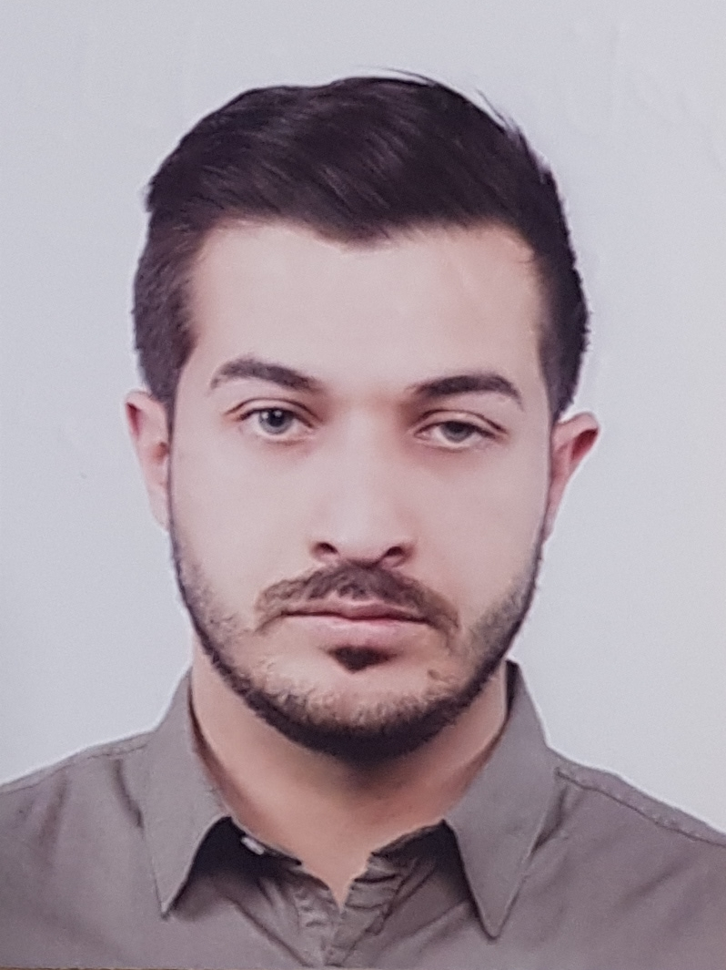

Address | Beirut southern suburb, Hadi nasrallah street.
Date of birth | 4th of July 1996
Nationality | Lebanese - Russian
Mobile | 00961 71652070
E-mail | bilalhnasser@hotmail.com

--------------------------------------------------------------------------------------------------------------------------

Personal Profile

| I am a highly motivated person, seeking new opportunities in professional organizations where I can prove and improve myself. Being self-motivated, I work hard at a task without cease until the completion.
I adapt well and am able to work on my own or within a team.
Overall, I am hard working, reliable, loyal and always willing to learn.

------------------------------------------------------------------------------------------------------------

Objectives

| Seeking a position within a reputable company that recognizes commitment, hard work and quality.

--------------------------------------------------------------------------------------------------------------------------

Education

| College Christ roi, zahle, Lebanon | 2014 Completed
(Degree: BACC 2 – Economic science)

| BIU, Mousaitba, Lebanon | 2015 until presence (3rd year)
Bachelor Degree in mechanical engineering (To be finalized by June 2018)

Languages

Arabic | Spoken, written, read (Fluent)
French | Spoken, written, read (Beginner)
English | Spoken, written, read (Intermediate)
Russian | Spoken, written, read (Beginner)

--------------------------------------------------------------------------------------------------------------------------

Work Experience

| Supervisor in Beirut restaurant Vladikavkaz, Russia
- Supervision of workers
- Opening count.
- End-day count.
- Survey on cleaning schedule.
- Provide supplies.

--------------------------------------------------------------------------------------------------------------------------

Conferences and Seminars

| Economic foundations of a free and prosperous Lebanon organized by LIMS (Lebanese institute for market study)

--------------------------------------------------------------------------------------------------------------------------

Computer Skills

| Microsoft Office
| Photoshop (Beginner)
| AutoCAD (intermediate)
| Various other

--------------------------------------------------------------------------------------------------------------------------

Interests & Hobbies

| Various sports
| Travelling
| Reading newspapers and politics

