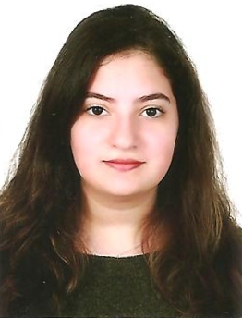
CURRICULUM VITAE:
Personal data:
Name : Joudi Souheil Saad
Details of birth : July 12th, 2000- Sin el fil
Nationality : Lebanese
Address : Sin El Fil, Mar Elias street, Saad building
Marital status : Single
Tel No : +9613506541
Email : joudisaad@live.com
Education Level:
2003-2018 : Collège des Pères Antonins- Hadath/Baabda
Lebanese Baccalaureate - Series Life Science
Languages Writing Speaking reading
Arabic good very good very good
English very good very good very good
French very good very good very good
About me:
I am an outgoing person, I love meeting and learning new things. Confident when working in groups and able to deal with a problem calmly and efficiently.
I like to draw and listen to music. I worked many times as a part time teacher for children in need.
Objective:
I am looking for a summer job to enhance and augment my knowledge and skill base.

