Jay’s Chocolatier Profile Concept

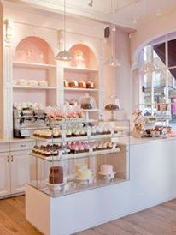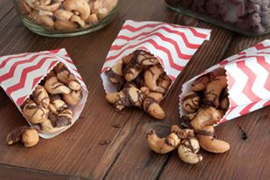
Jay’s Chocolatier is an American mix Chocolate clusters specialty to bring to Lebanon.
Hand made with fresh ingredients with all types of Chocolates and stuffing.
We are retail business looking forward to expand in Lebanon with our signature products.

