KUMPIR
B a k e d P o t a t o

- What is kumpir?

Kumpir is a unique way of serving baked potatoes. It consists of a baked potato mixed with butter, cheese and choice of several delicious toppings…

- This idea began in turkey and it was spread in several regions of the world: North America, United Kingdom, France, etc...

- In basic form, it is made with potatoes that are wrapped with foil and baked in special ovens.

- Needs required:

- Electricity
- Water installation
- 4 x 3 sqm

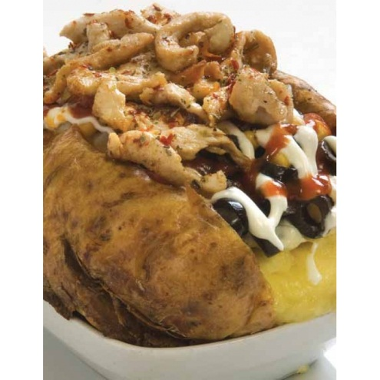




PS: A mid-size baked potato gives you only 100 calories comparing to apple and pear, kumpir has more vitamin C in it and it gives all the daily vitamin C & B as per zinc also that human body required for the day

