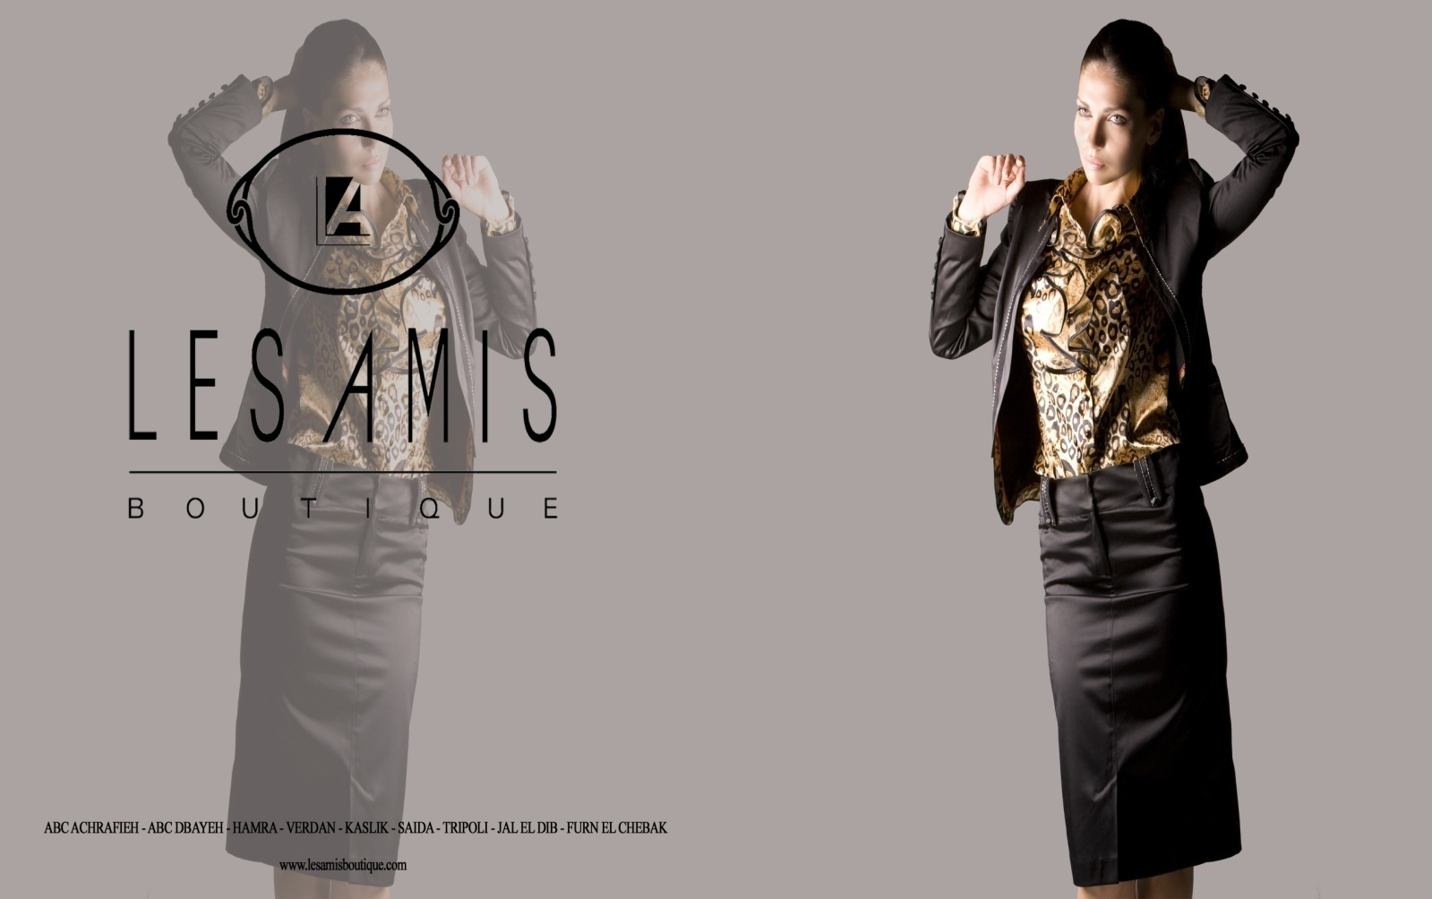

Our Vision
We seek perfection; we cherish beauty and style within the fashion industry, and we aim at maintaining our name and reputation at the top of the minds of our targeted consumers.

Our Mission
LES AMIS s.a.r.l. is leading Fashion Retail Company that engages in offering a range of garments and accessories targeted for females. The current activities of LES AMIS are set in the Lebanese market and this through the prime location stand-alone shops or branches within leading department stores.
LES AMIS s.a.r.l. aims at maintaining the highest standards in terms of customer servicing, the highest quality of product range, selection and offering and this to satisfy the needs of the target market and maintain the organization's image and reputation in the Lebanese market.

Our Values
We value the relations that we build with our suppliers. We handpick our suppliers to ensure a synergy between our existing selection and our potential collections. We look forward to developing professional and ethical relationship in order to enhance our value chain and maintain our reputation at its best.

We value our team members; we provide equal opportunities to all of our potential candidates and employees in terms of recruitment for the former and promotions for the later. LES AMIS s.a.r.l. ensures thorough trainings for the retail team members as well as the office team members.

Our Target Audience
Our customers are our priority; in order to serve out target efficiently, we understand their lifestyles, experiences and desires. LES AMIS's vocation is to meet and succeed the customer's expectations.

We can define our main target as follows:
- Gender: Females
- Age group: [25 and above[
- Has a reasonable to high level of education
- Middle to high spending power
- Belongs to Middle to upper social class
- Is mature
- Exposed to the fashion scene and sophisticated
- Exposed to the local, regional and international media and happenings

Our Product Categories
On the retail level, we present out product through three main lines:
- The Special Occasions: sophisticated, thought with high detail, and is aimed for those customers attending special events and occasions.
- The City Wear: A core line that forms the majority of the collection; aimed at filling the needs of the active women who seeks style and distinctiveness on a daily basis.
- The Casual Wear: reflects the personality of women who seek comfort and quality in the selected wardrobe.
The weight of the collection is thought to match the yearly calendar scheme of events, festivities and local seasonal benchmarks; this provides the shop with a relevant and comprehensive offering at all times and throughout the year.

Our Positioning
LES AMIS is on the top of the mind awareness when it comes to the following:
- Occasions suits and outfits.
- Special occasions and evening wear (Weddings, engagements, gala and receptions dresses).
- High quality jumpers and twin sets.
- Distinguished coats, jackets and dresses.

Our History and Growth
LES AMIS s.a.r.l. was founded in Beirut, Lebanon in 1996, and till date is synonym to quality standards in the local fashion industry.
- LES AMIS BOUTIQUE is a fashion retail boutique that offers women garments and accessories.
- LES AMIS BOUTIQUE is recognized for its highest quality of customer service, relevant range of offering and distinguished product range, thus placing the brand as a major fashion retailer in the Lebanese Fashion Community.
- The collection at LES AMIS BOUTIQUE is thought to fit out target's needs and desires and to stand out from the offering that is presented on the high street.
- LES AMIS BOUTIQUE operates across the country in prime locations enabling a strategic approach to answering the target market's special needs in distinguished areas/cities.
our ability to continuously adapt to changes in the Lebanese market and surrounding environment help in sustaining our positioning and refreshing our brand, hence continuously ensuring an added value to our customers at all times.

Our Office Address and Registrations
LES AMIS s.a.r.l registration number: 56922- R.C.
Registration year: 1996

Business Address: Dora St. Maroun Street- El Edaimi Building, 2nd Floor- Beirut, Lebanon
Telephone: 00961 1 266138; 00961 1 244177
Fax: 00961 1 268677
Website: www.lesamisboutique.com
Email: lesamis@lesamisboutique.com

Our Locations
LES AMIS s.a.r.l head office is located in Beirut, Dora.
LES AMIS BOUTIQUE operates in prime locations all over the Lebanese territory. The choice of our location is done with careful attention to the at the locations' customer type, rate of customer dwelling and accessibility.
We operate in 9 prime locations listed below:
- ABC Mall, Achrafieh, Level 1
- ABC Mall, Dbayeh highway, Level 2
- Jal El Dib, Main street, Oscar center
- Hamra, Main street, Broadway center
- Kaslik, Main road, Facing century park hotel
- Saida, Boulevard zazih al darzi, Center zaatri
- Tripoli, Nadin el jisir street, Masri and tabbara center
- Verdun, Main road, Facing goodies
- Furn el Chebbak, Main road, Chalfoun center
Our flagship store in Downtown Beirut (Souks area) is due in 2011;
Our sister company BASICS is specialized in Women's wear and Men's wear shoes and bags. The product range is a selection of renowned brands of high quality and exclusive designs.
Our shops are continuously lifted to fit the modern trends in retail visual merchandising and retail decorations, also, the shop lifting is a major initiative that we invest in as part of maintaining a clean and attractive view of our shops.

Our organization
There are three major sections that form LES AMIS s.a.r.l: The head office, the warehouse and the retail outlets.
The retail outlets and the warehouse are directed through the head office; we aim at maintaining centralization to maintain a level of control and ensure the delivery of a high quality level of work throughout our supply chain.
- The owners of the company dedicate their efforts into working closely with the team members in order to reach the desired goals.
- The retail manager works under the guidance of the owners and ensures the achievement of set goals and this through thorough follow up of the performance of the retail outlets, the team members, the communications goals, the merchandise and so on.
- On the retail level, every outlet consists of a shop manager, an assistant shop manager, a cashier and sales representatives. When recruiting potential managers, the candidates undertake training about the company's rules, regulations and procedures.
- We work closely with our team in order to assure a high level or customer service since we aim at providing standards and value to our customers.
- On the warehouse level, the inventory manager and the assistant inventory manager work with the stock keepers to keep the stocks coordinated and organized. The team members in the warehouse understand the importance of stock management and stock organization, and understand that the main priority is taking care of the product at all times.
- The visual merchandiser and allocator work closely with the retail manager to maintain a healthy rotation of merchandise and a neat look of the shop floor and the shop windows at all times.

Our Procedures
For the sake of maintaining a unique perception of our shops and "speak the same language" the team members of LES AMIS BOUTIQUES follow the notes and procedures booklet. The procedures booklet contains all the necessary information about the daily operational tasks that should be performed as well as the internal rules and regulations followed with the services standards of the company.

Safety Regulations and Waste Management
- LES AMIS ensures safety standards to secure personnel at the work place.
- Fire extinguishers are located in every shop; Team members are informed about the safety procedures in case of emergencies.
- At the till point of every shop, emergency numbers are put at the disposal of the team members
- We pay attention to our shops' neatness and that of the environment. We make sure that our shops are clean at all times and that the collection of waste is performed on a daily basis.
- We aim at becoming "green" activists in the near future; therefore we have started saving on paper usage as much as possible and cutting down on unnecessary use of paper and nylon bags, and this throughout all of the members of our supply chain.

Our Shop Coordination
There is a constant and thorough planning of the way the merchandise is sent to the shops. We endeavor at following the logic of:
- Taking into consideration the location and the market footfall at this location
- The competition at the certain location
- The shop's history in terms of families'/departments' performances
- The best and worst sellers
- The visual coordination in terms or style, color, and fabric
- The shops' capacity
- The communications plans

